**Excel Assignment 5**

1. What is a ribbon in Excel?
   1. Ribbon in Excel helps us to use multiple features which used for performing functions, it can be switched b\w multiple elements to perform different tasks. IT consists from HOME to HELP, each menu has different operations inside
2. What is the order of operations used for evaluating formulas in excel?
   1. It follows PEMDAS acronym (Parentheses, Exponents, Multiplication, Division, Addition, Subtraction)
3. Reverse the string in the excel column and check whether the string is palindrome or not in the next column for each value.

|  |  |  |
| --- | --- | --- |
| **Word** | **Reverse Word** | **Is Palindrome** |
| EYE | EYE | TRUE |
| EAR | RAE | FALSE |

1. Is it possible to protect value from being copied from the cell? If yes, then how to implement it.
   1. Yes its possible by setting password as protect sheet from Review tab

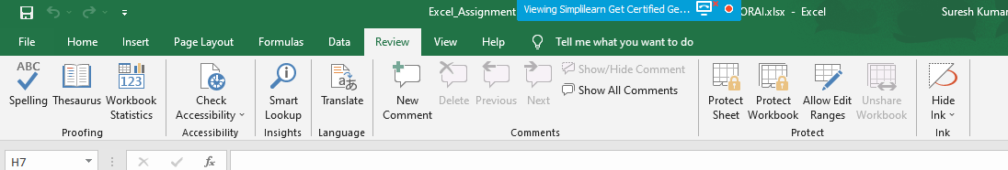

1. What is the use of Name Box in MS-Excel?
   1. Below pic displays the name box, which can be changed as per our request

